Microsoft FrontPage

Change the background color of a page
- Click Format on the Menu bar and select Background.
- Click the Background tab, if not selected.
- In the Colors section, click the Background drop-down box and select a color.
- Click OK

Formatting text
- Text can be formatted using the buttons on the Format toolbar by selecting Format/Font on the Menu bar.

Add clip art
- Select Image/Picture/Clip Art from the Menu bar. The Clip Art Task Menu appears.
- Type in a keyword next under Search.
- Click on the picture you want to add.

TIP: Some people shut off their image display when they visit Web sites - which means they see only text and no pictures. Not everyone wants to see pictures because it takes longer to download a page that contains them. For those visitors, you can provide alternative text in place of the images.
NOTE: Alternative text also makes your Web site accessible to the blind or visually impaired. These visitors use screen readers that will look for the alternative text and describe the images to them.
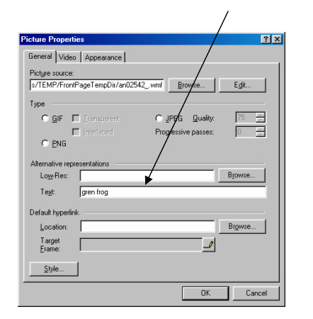
To add alternative text to an image
- Place the pointer on the image and right-click. A pop-up menu appears.
- Click on Picture Properties
- Click the General tab
- Type the alternative text into the Alternative Representations Text box.When previewing/viewing the website, visitors will see the text when they hold the mouse pointer over the picture.

Add images from other sources  - Select Insert/Picture from File on the Menu Bar.  - The picture window appears.  - Click the Select a file on your computer button  - Locate the image file on the computer and select it.  - Click OK in the Select File window  - Click OK in the Picture window | 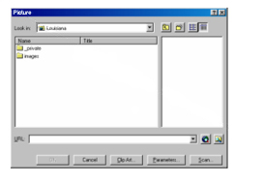

To position text and pictures
- Select the image or text to position.
- Select Format/Position from the Menu bar The Position window appears.
- Select a wrapping style and a positioning style.
- Click OK

To give an image a transparent background
This option works well when you want to blend an object into your web page background - but it will only work with .gif images.
- Select the image by clicking on it.
- Click the Set Transparent Color button on the Image toolbar.
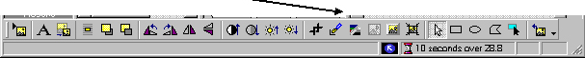
- The cursor will turn into a pencil icon.
- Position the pencil icon over the color. Click the color.

To make text into a hyperlink
- Select the text that will be hyperlinked.
- Click the Hyperlink button on the toolbar. The Create Hyperlink window appears.
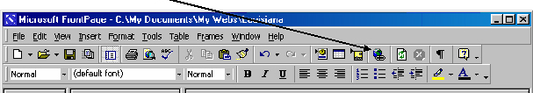
- Find and click the file name of the page you want to link to if you are linking to another page you created or type the URL of the web site you want to link to.
- Click OK

To make an image a hyperlink
- Select the image by clicking it.
- Click the Hyperlink button on the toolbar. The Create Hyperlink window appears
- Find and click the file name of the page you want to link to if you are linking to another page you created or type the URL of the web site you want to link to.
- Click OK

To create an e-mail hyperlink
- Select the text or image by clicking on it.
- Click the Hyperlink button on the toolbar.
- Click the Make a hyperlink that sends an email (the envelope) button in the Create Hyperlink window.
- Type the e-mail address in the text box.
- Click OK

To preview your web site in your browser
- Click the Preview in Browser button on the toolbar.
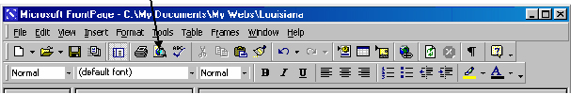
- The computer opens a browser with the web page in it.

Adding Metatags
- Open the Web page that you want to add a keywords meta tag to.
- On the File menu, click Properties, and then click the Custom tab.
- Under User variables, click Add.
- In the Name box, type keywords.
- In the Value box, type the index keywords for your site, using commas to separate the words.
- Click OK twice.

